# Leaf Controller

We will call Leaf Controller to the Linux System (BananaPi-R2 or ExpressoBin-Ultra or ModBerry) plus the Controllino-Mega:

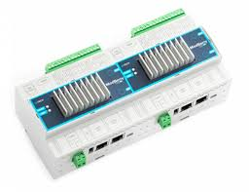

ModBerry

EspressoBin-Ultra

BananaPi-R2

Controllino-Mega

**Linux System**

BananaPi-R2

EspressoBin-Ultra

ModBerry

Controllino-Mega

Ethernet

USB

# Development Environment

For the Linux System Development Environment, we’ll use PyCharm running on a Windows laptop.

The project is found in **\FEleafcontroller\Linux-Python**.

The Linux System runs a Python program, whose files are:

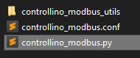

Controllino_modbus.py contains the main, controllino_modbus.conf is the configuration file, and the controllino_modbus_utils directory contains device specific definitions and code.

For the Controllino Development Environment, we’ll use Atmel Studio.

The Atmel Studio project solution can be found in **\FEleafcontroller\Controllino-AtmelStudio\Controllino**.

# qModMaster communication with Controllino

qModMaster (unzip qModMaster-Win64-exe-0.5.3-beta.zip, executable qModMaster.exe, https://sourceforge.net/projects/qmodmaster/) can be used to dialog to the Controllino through the Ethernet interface.

1. Configure the Windows laptop to have address 192.168.2.10

1. Connect a direct Ethernet cable between the Windows laptop and the Controllino
2. The Controllino has address 192.168.2.3 port 502, so in QModMaster select “Options | Modbus TCP…” and set

1. Use qModMaster to write Outputs and read Inputs, using Unit ID 42, and the proper Modbus Function Code.

qModMaster Start address is 1, whereas in the LeafController Linux-Python is 0!

# qModMaster communication with the LeafController Linux-Python

In order to communicate directly with the LeafController Linux-Python:

1. Configure the Windows laptop to have address 192.168.2.10

1. Graphical user interface, application

   Description automatically generatedPerform a loopback connection to the Windows laptop on address 192.168.2.10 port 1502, so in QModMaster select “Options | Modbus TCP…” and set
2. Use qModMaster to read Input Registers, using Unit ID 42, and the proper Modbus Function Code.

qModMaster Start address is 1, whereas in the LeafController Linux-Python is 0!

So, to read the variables in controllino_controllino.py:

['aggTripAlarmCore', 0x182A, 0xAB, 'ro', 'v'], # address 6186

['aggTripAlarmCube', 0x182B, 0xBA, 'ro', 'v'] # address 6187

# WireShark

WireShark can be used to capture the traffic between the Linux System and the Controllino.

The filter ‘**ip.addr == 192.168.2.3 and modbus’** is useful to catch only the Modbus traffic that flows through the Controllino, IP address 192.168.2.3.

Allowing to inspect the Ethernet / Modbus TCP:

# Connecting the DL-10 Temperature and Humidity Sensor

Connect the DL-10 to the Windows laptop using a RS485 to USB converter. It’s necessary to connect the power of DL-10 to a power supply of 12VDC and the RS485 between the DL-10 the RS485 to USB converter.

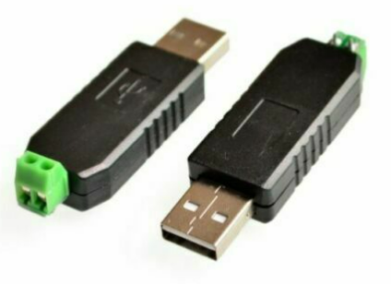

Use the DL-10 software, **DCON_Utility_Pro_PC DCON_Utility_Pro.exe**, to scan for the DL-10.

Be sure that you are using the right COM port by pressing the “COM Port” toolbar button, and then initiate the scan by pressing the “Start Search”.

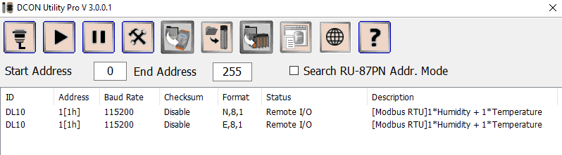

This proofs that the DL-10 is working.

## Changing DL-10 configuration

Now the DL-10 must have its configurations changed to be integrated

The Controllino uses 19200,N,8,1 and the DL-10 should have the Address 5. So, these need to be changed.

1. Power off the DL-10.
2. Change the switch on the back of the DL-10 to the Init position which allows to change the configuration.

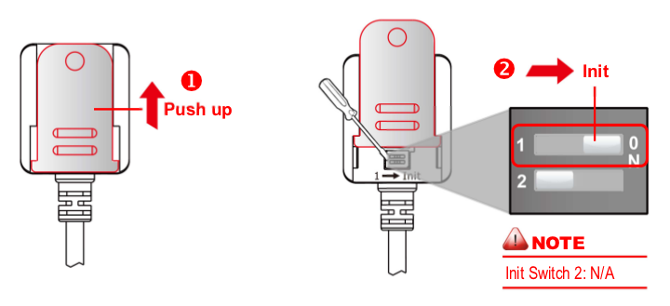

1. Power the DL-10.
2. Perform a new scan.

The module should be found again:

1. Graphical user interface, text, application

   Description automatically generatedJust double-click on the line that contains the DL10 N,8,1 and change the configuration to:

Once “Set Module Configurations” is pressed a message at the bottom of the window should appeared:

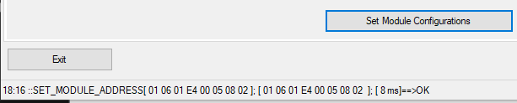

Followed by another window:

1. Disconnect the DL-10 power.
2. Change the switch to position 1 (to the left): Diagram

   Description automatically generated
3. Change the com port to scan only on 19200, by default only 115200 and 9600 are used.

1. Repower the module and rescan.

Now the module should be found at address 5 with the communications parameters of 19200,N,8,1.

Double-click on the module and check if the temperature and humidity are read and make sense.

1. Exit the DCON Utility and as a second proof use qModMaster to verify these readings.

qModMaster needs to be used with the following parameters:

The 2 values read are by order, the Humidity, and the Temperature, with a factor of x100.

As above, 40.61% of Humidity and 24.88C of Temperature.

1. Connect the DL-10 to the Controllino RS485 Modbus network.

To verify that this is working, open the Linux-Python project and place a breakpoint in file controllino_generic_modbus.py on the line shown below in blue.

When the program hits the breakpoint verify that is a read of the DL-10, by checking variable results, field unit_id == 5 and then inspect the registers field.

0 is the Humidity, 1 is the Temperature in C, 2 is the Temperature in F.

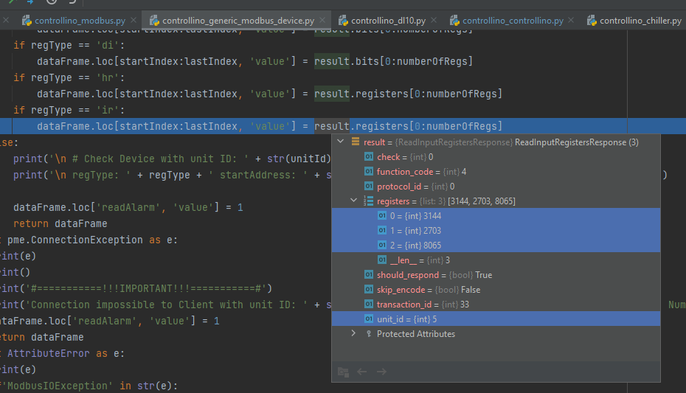

## Writing a Controllino digital Output

The qModMaster can be used to write an output of the Controllino (coil)

Run the Controllino_modbus.py and establish a connection to 192.168.2.10 (that’s the laptop where the Python and qModMaster are running, so a loopback) and using the parameters shown below execute the write.

This will hit the python function writeToClients().

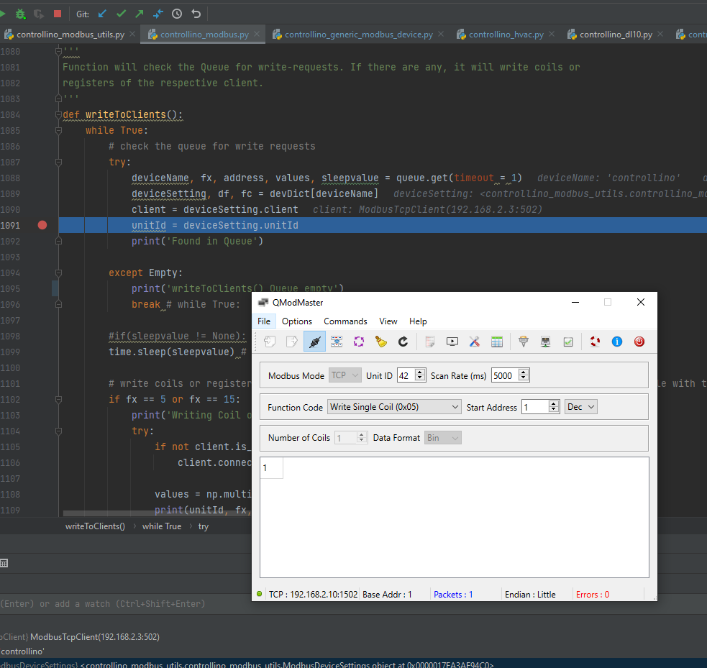

## Writing multiple Controllino Outputs

Multiple outputs can be written as well, up to 16. Function writeToClients is also used.

# Creating a Linux SDcard for BananaPi R2

For this purpose, balenaEtcher software can be used, <https://www.balena.io/etcher/>

The file to be used is **fluence_202111221625_master.img.gz**.

